1 run......

Downloading: 100%

268M/268M [00:08<00:00, 32.9MB/s]

training 1 epoch...

59.92681956291199 seconds used......

1 training finished! average train loss: 0.6698092974722385

evaluating...

Confusion matrix, without normalization

[[ 83 41 66]

[ 61 275 79]

[ 57 21 635]]

Normalized confusion matrix

[[0.43684211 0.21578947 0.34736842]

[0.14698795 0.6626506 0.19036145]

[0.0799439 0.02945302 0.89060309]]

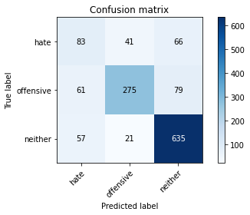

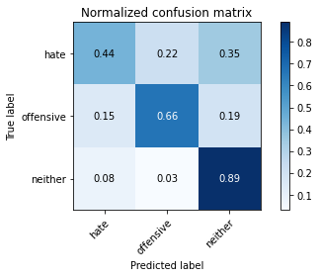

precision recall f1-score support

hate 0.41 0.44 0.42 190

offensive 0.82 0.66 0.73 415

neither 0.81 0.89 0.85 713

accuracy 0.75 1318

macro avg 0.68 0.66 0.67 1318

weighted avg 0.76 0.75 0.75 1318

average eval_loss: 0.6091564934362065, accuracy: 0.7534142640364189

training 2 epoch...

58.87596821784973 seconds used......

2 training finished! average train loss: 0.4750637178393928

evaluating...

Confusion matrix, without normalization

[[ 31 86 73]

[ 23 328 64]

[ 24 54 635]]

Normalized confusion matrix

[[0.16315789 0.45263158 0.38421053]

[0.05542169 0.79036145 0.15421687]

[0.03366059 0.07573633 0.89060309]]

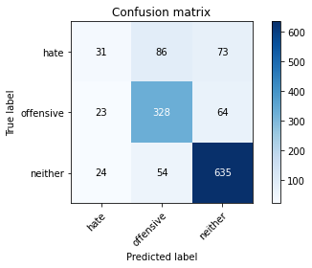

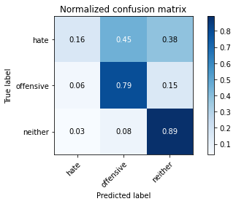

precision recall f1-score support

hate 0.40 0.16 0.23 190

offensive 0.70 0.79 0.74 415

neither 0.82 0.89 0.86 713

accuracy 0.75 1318

macro avg 0.64 0.61 0.61 1318

weighted avg 0.72 0.75 0.73 1318

average eval_loss: 0.610449547568957, accuracy: 0.7541729893778453

training 3 epoch...

59.03280758857727 seconds used......

3 training finished! average train loss: 0.31832599729638206

evaluating...

Confusion matrix, without normalization

[[ 61 75 54]

[ 29 330 56]

[ 62 73 578]]

Normalized confusion matrix

[[0.32105263 0.39473684 0.28421053]

[0.06987952 0.79518072 0.13493976]

[0.08695652 0.10238429 0.81065919]]

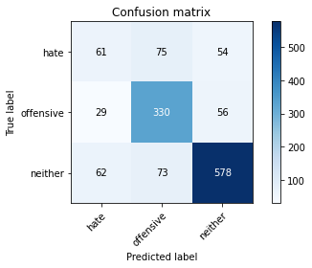

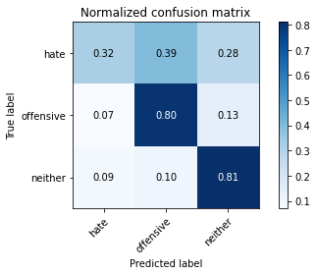

precision recall f1-score support

hate 0.40 0.32 0.36 190

offensive 0.69 0.80 0.74 415

neither 0.84 0.81 0.83 713

accuracy 0.74 1318

macro avg 0.64 0.64 0.64 1318

weighted avg 0.73 0.74 0.73 1318

average eval_loss: 0.6903732920234854, accuracy: 0.7352048558421851

training 4 epoch...

59.07178044319153 seconds used......

4 training finished! average train loss: 0.16660734476860273

evaluating...

Confusion matrix, without normalization

[[ 51 76 63]

[ 40 319 56]

[ 63 59 591]]

Normalized confusion matrix

[[0.26842105 0.4 0.33157895]

[0.09638554 0.7686747 0.13493976]

[0.08835905 0.08274895 0.82889201]]

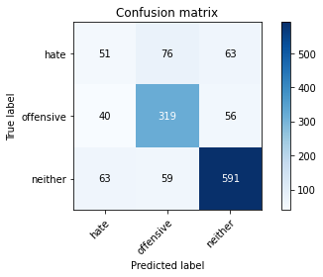

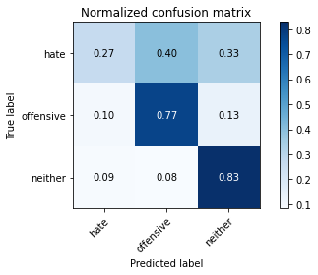

precision recall f1-score support

hate 0.33 0.27 0.30 190

offensive 0.70 0.77 0.73 415

neither 0.83 0.83 0.83 713

accuracy 0.73 1318

macro avg 0.62 0.62 0.62 1318

weighted avg 0.72 0.73 0.72 1318

average eval_loss: 0.8949583073457082, accuracy: 0.7291350531107739

training 5 epoch...

59.07504439353943 seconds used......

5 training finished! average train loss: 0.07262238078242676

evaluating...

Confusion matrix, without normalization

[[ 44 80 66]

[ 42 326 47]

[ 69 69 575]]

Normalized confusion matrix

[[0.23157895 0.42105263 0.34736842]

[0.10120482 0.78554217 0.11325301]

[0.09677419 0.09677419 0.80645161]]

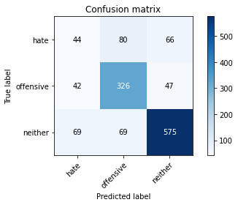

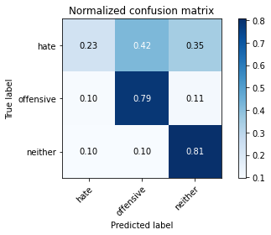

precision recall f1-score support

hate 0.28 0.23 0.26 190

offensive 0.69 0.79 0.73 415

neither 0.84 0.81 0.82 713

accuracy 0.72 1318

macro avg 0.60 0.61 0.60 1318

weighted avg 0.71 0.72 0.71 1318

average eval_loss: 1.1682988906448537, accuracy: 0.7169954476479514

training 6 epoch...

58.88748526573181 seconds used......

6 training finished! average train loss: 0.05837081743891097

evaluating...

Confusion matrix, without normalization

[[ 41 91 58]

[ 37 327 51]

[ 64 76 573]]

Normalized confusion matrix

[[0.21578947 0.47894737 0.30526316]

[0.08915663 0.78795181 0.12289157]

[0.08976157 0.10659187 0.80364656]]

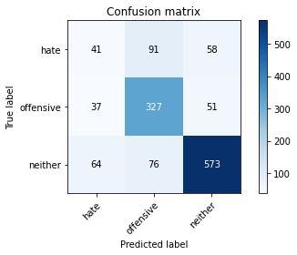

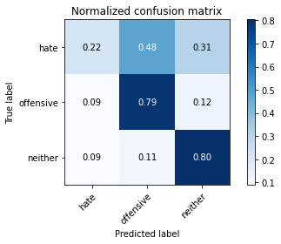

precision recall f1-score support

hate 0.29 0.22 0.25 190

offensive 0.66 0.79 0.72 415

neither 0.84 0.80 0.82 713

accuracy 0.71 1318

macro avg 0.60 0.60 0.60 1318

weighted avg 0.70 0.71 0.71 1318

average eval_loss: 1.214316342364658, accuracy: 0.7139605462822458

training 7 epoch...

58.86970543861389 seconds used......

7 training finished! average train loss: 0.03165660241528795

evaluating...

Confusion matrix, without normalization

[[ 53 85 52]

[ 49 318 48]

[ 99 59 555]]

Normalized confusion matrix

[[0.27894737 0.44736842 0.27368421]

[0.11807229 0.76626506 0.11566265]

[0.13884993 0.08274895 0.77840112]]

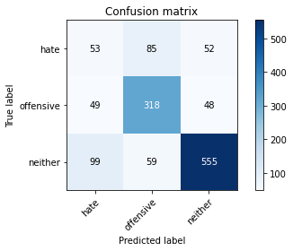

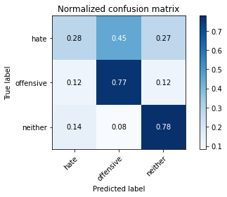

precision recall f1-score support

hate 0.26 0.28 0.27 190

offensive 0.69 0.77 0.73 415

neither 0.85 0.78 0.81 713

accuracy 0.70 1318

macro avg 0.60 0.61 0.60 1318

weighted avg 0.71 0.70 0.71 1318

average eval_loss: 1.3140248136989998, accuracy: 0.7025796661608498

training 8 epoch...

58.87159442901611 seconds used......

8 training finished! average train loss: 0.018352862507692243

evaluating...

Confusion matrix, without normalization

[[ 62 77 51]

[ 53 321 41]

[ 94 63 556]]

Normalized confusion matrix

[[0.32631579 0.40526316 0.26842105]

[0.12771084 0.77349398 0.09879518]

[0.13183731 0.08835905 0.77980365]]

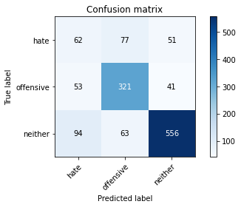

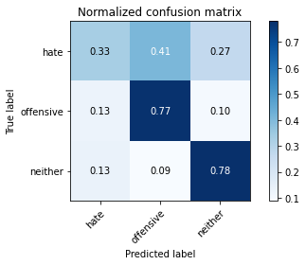

precision recall f1-score support

hate 0.30 0.33 0.31 190

offensive 0.70 0.77 0.73 415

neither 0.86 0.78 0.82 713

accuracy 0.71 1318

macro avg 0.62 0.63 0.62 1318

weighted avg 0.73 0.71 0.72 1318

average eval_loss: 1.48505782177954, accuracy: 0.712443095599393

training 9 epoch...

58.99832820892334 seconds used......

9 training finished! average train loss: 0.018457924198380417

evaluating...

Confusion matrix, without normalization

[[ 37 106 47]

[ 28 350 37]

[ 69 110 534]]

Normalized confusion matrix

[[0.19473684 0.55789474 0.24736842]

[0.06746988 0.84337349 0.08915663]

[0.09677419 0.1542777 0.74894811]]

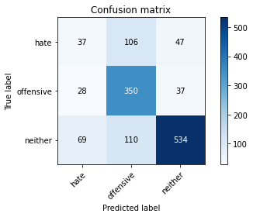

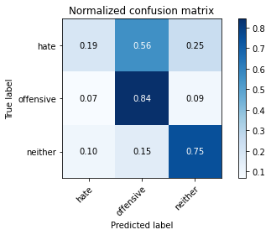

precision recall f1-score support

hate 0.28 0.19 0.23 190

offensive 0.62 0.84 0.71 415

neither 0.86 0.75 0.80 713

accuracy 0.70 1318

macro avg 0.59 0.60 0.58 1318

weighted avg 0.70 0.70 0.69 1318

average eval_loss: 1.6099773482842878, accuracy: 0.6987860394537178

training 10 epoch...

58.923834800720215 seconds used......

10 training finished! average train loss: 0.026961112193914068

evaluating...

Confusion matrix, without normalization

[[ 64 65 61]

[ 67 303 45]

[ 97 60 556]]

Normalized confusion matrix

[[0.33684211 0.34210526 0.32105263]

[0.16144578 0.73012048 0.10843373]

[0.13604488 0.08415147 0.77980365]]

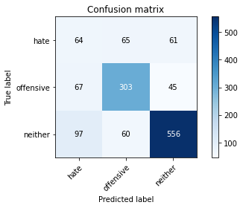

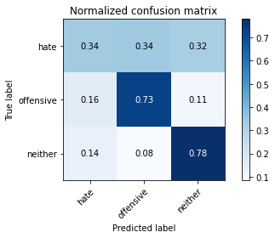

precision recall f1-score support

hate 0.28 0.34 0.31 190

offensive 0.71 0.73 0.72 415

neither 0.84 0.78 0.81 713

accuracy 0.70 1318

macro avg 0.61 0.62 0.61 1318

weighted avg 0.72 0.70 0.71 1318

average eval_loss: 1.4709406287381144, accuracy: 0.7003034901365706

2 run......

training 1 epoch...

58.88573098182678 seconds used......

1 training finished! average train loss: 0.6625472339039499

evaluating...

Confusion matrix, without normalization

[[ 34 71 85]

[ 14 301 100]

[ 15 26 672]]

Normalized confusion matrix

[[0.17894737 0.37368421 0.44736842]

[0.03373494 0.7253012 0.24096386]

[0.02103787 0.03646564 0.94249649]]

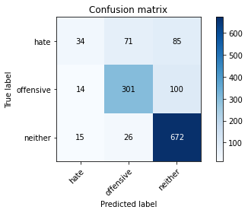

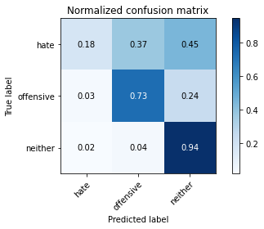

precision recall f1-score support

hate 0.54 0.18 0.27 190

offensive 0.76 0.73 0.74 415

neither 0.78 0.94 0.86 713

accuracy 0.76 1318

macro avg 0.69 0.62 0.62 1318

weighted avg 0.74 0.76 0.73 1318

average eval_loss: 0.5802423114126379, accuracy: 0.7640364188163885

training 2 epoch...

58.94425678253174 seconds used......

2 training finished! average train loss: 0.4733554808930917

evaluating...

Confusion matrix, without normalization

[[ 30 107 53]

[ 12 365 38]

[ 20 117 576]]

Normalized confusion matrix

[[0.15789474 0.56315789 0.27894737]

[0.02891566 0.87951807 0.09156627]

[0.02805049 0.16409537 0.80785414]]

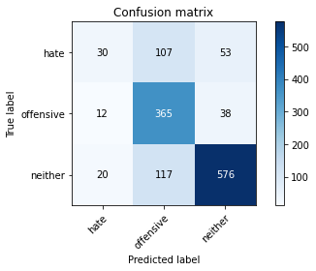

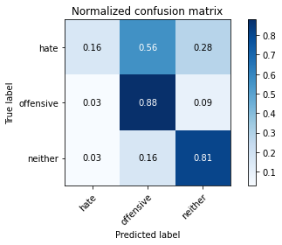

precision recall f1-score support

hate 0.48 0.16 0.24 190

offensive 0.62 0.88 0.73 415

neither 0.86 0.81 0.83 713

accuracy 0.74 1318

macro avg 0.66 0.62 0.60 1318

weighted avg 0.73 0.74 0.71 1318

average eval_loss: 0.6587217581091505, accuracy: 0.7367223065250379

training 3 epoch...

59.00644087791443 seconds used......

3 training finished! average train loss: 0.3237973595800048

evaluating...

Confusion matrix, without normalization

[[ 29 80 81]

[ 19 314 82]

[ 19 51 643]]

Normalized confusion matrix

[[0.15263158 0.42105263 0.42631579]

[0.04578313 0.75662651 0.19759036]

[0.02664797 0.07152875 0.90182328]]

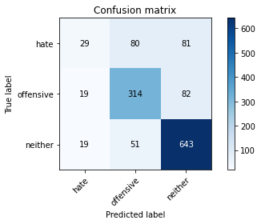

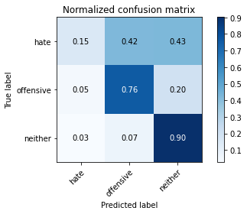

precision recall f1-score support

hate 0.43 0.15 0.23 190

offensive 0.71 0.76 0.73 415

neither 0.80 0.90 0.85 713

accuracy 0.75 1318

macro avg 0.65 0.60 0.60 1318

weighted avg 0.72 0.75 0.72 1318

average eval_loss: 0.6782025414885897, accuracy: 0.7481031866464339

training 4 epoch...

58.95928692817688 seconds used......

4 training finished! average train loss: 0.16940716925124766

evaluating...

Confusion matrix, without normalization

[[ 36 92 62]

[ 19 348 48]

[ 49 92 572]]

Normalized confusion matrix

[[0.18947368 0.48421053 0.32631579]

[0.04578313 0.83855422 0.11566265]

[0.0687237 0.12903226 0.80224404]]

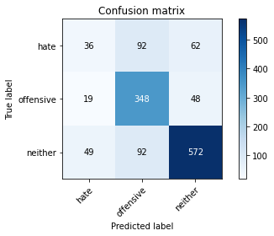

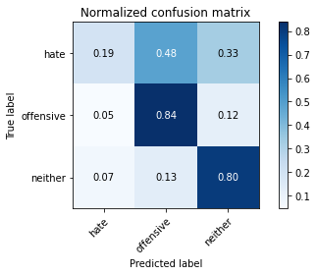

precision recall f1-score support

hate 0.35 0.19 0.24 190

offensive 0.65 0.84 0.73 415

neither 0.84 0.80 0.82 713

accuracy 0.73 1318

macro avg 0.61 0.61 0.60 1318

weighted avg 0.71 0.73 0.71 1318

average eval_loss: 0.9619365126797648, accuracy: 0.7253414264036419

training 5 epoch...

58.89670968055725 seconds used......

5 training finished! average train loss: 0.08192650651008906

evaluating...

Confusion matrix, without normalization

[[ 49 84 57]

[ 30 334 51]

[ 70 63 580]]

Normalized confusion matrix

[[0.25789474 0.44210526 0.3 ]

[0.07228916 0.80481928 0.12289157]

[0.09817672 0.08835905 0.81346424]]

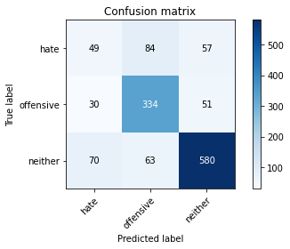

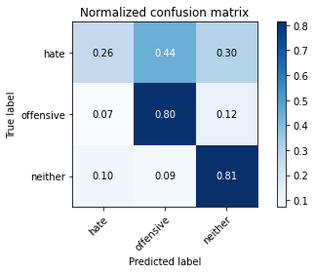

precision recall f1-score support

hate 0.33 0.26 0.29 190

offensive 0.69 0.80 0.75 415

neither 0.84 0.81 0.83 713

accuracy 0.73 1318

macro avg 0.62 0.63 0.62 1318

weighted avg 0.72 0.73 0.72 1318

average eval_loss: 1.1049171790029064, accuracy: 0.7306525037936267

training 6 epoch...

58.87641882896423 seconds used......

6 training finished! average train loss: 0.055198910685298454

evaluating...

Confusion matrix, without normalization

[[ 71 68 51]

[ 46 331 38]

[ 99 49 565]]

Normalized confusion matrix

[[0.37368421 0.35789474 0.26842105]

[0.11084337 0.79759036 0.09156627]

[0.13884993 0.0687237 0.79242637]]

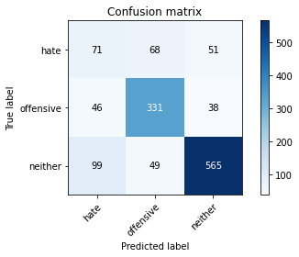

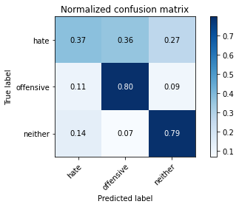

precision recall f1-score support

hate 0.33 0.37 0.35 190

offensive 0.74 0.80 0.77 415

neither 0.86 0.79 0.83 713

accuracy 0.73 1318

macro avg 0.64 0.65 0.65 1318

weighted avg 0.75 0.73 0.74 1318

average eval_loss: 1.1272800054514047, accuracy: 0.7336874051593323

training 7 epoch...

58.813820123672485 seconds used......

7 training finished! average train loss: 0.03817214388797187

evaluating...

Confusion matrix, without normalization

[[ 83 64 43]

[ 59 322 34]

[107 56 550]]

Normalized confusion matrix

[[0.43684211 0.33684211 0.22631579]

[0.14216867 0.77590361 0.08192771]

[0.15007013 0.07854137 0.7713885 ]]

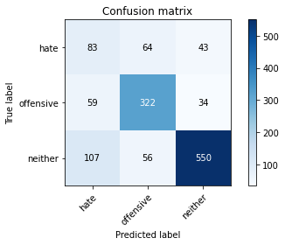

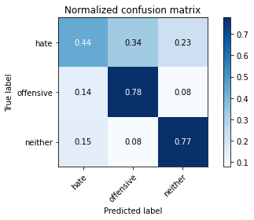

precision recall f1-score support

hate 0.33 0.44 0.38 190

offensive 0.73 0.78 0.75 415

neither 0.88 0.77 0.82 713

accuracy 0.72 1318

macro avg 0.65 0.66 0.65 1318

weighted avg 0.75 0.72 0.74 1318

average eval_loss: 1.1839545518159866, accuracy: 0.7245827010622155

training 8 epoch...

58.81949067115784 seconds used......

8 training finished! average train loss: 0.028196204726489007

evaluating...

Confusion matrix, without normalization

[[ 68 66 56]

[ 44 327 44]

[ 87 48 578]]

Normalized confusion matrix

[[0.35789474 0.34736842 0.29473684]

[0.1060241 0.78795181 0.1060241 ]

[0.12201964 0.06732118 0.81065919]]

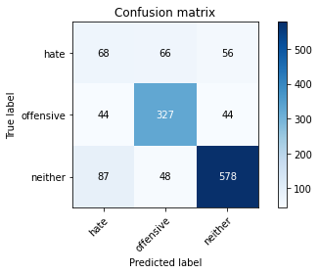

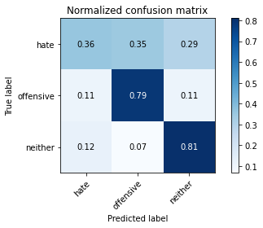

precision recall f1-score support

hate 0.34 0.36 0.35 190

offensive 0.74 0.79 0.76 415

neither 0.85 0.81 0.83 713

accuracy 0.74 1318

macro avg 0.65 0.65 0.65 1318

weighted avg 0.74 0.74 0.74 1318

average eval_loss: 1.3016089889587779, accuracy: 0.7382397572078907

training 9 epoch...

58.84407925605774 seconds used......

9 training finished! average train loss: 0.020398191112591037

evaluating...

Confusion matrix, without normalization

[[ 66 67 57]

[ 53 319 43]

[ 84 55 574]]

Normalized confusion matrix

[[0.34736842 0.35263158 0.3 ]

[0.12771084 0.7686747 0.10361446]

[0.11781206 0.07713885 0.80504909]]

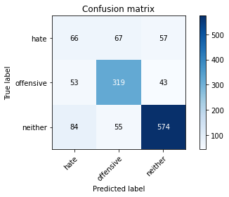

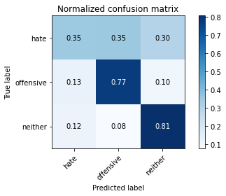

precision recall f1-score support

hate 0.33 0.35 0.34 190

offensive 0.72 0.77 0.75 415

neither 0.85 0.81 0.83 713

accuracy 0.73 1318

macro avg 0.63 0.64 0.64 1318

weighted avg 0.74 0.73 0.73 1318

average eval_loss: 1.297347062013366, accuracy: 0.7276176024279211

training 10 epoch...

58.8258957862854 seconds used......

10 training finished! average train loss: 0.013558931287810662

evaluating...

Confusion matrix, without normalization

[[ 47 69 74]

[ 30 325 60]

[ 51 46 616]]

Normalized confusion matrix

[[0.24736842 0.36315789 0.38947368]

[0.07228916 0.78313253 0.14457831]

[0.07152875 0.06451613 0.86395512]]

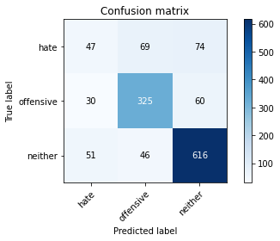

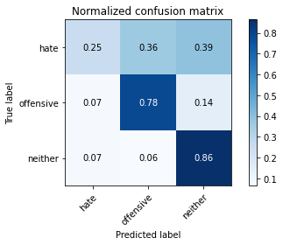

precision recall f1-score support

hate 0.37 0.25 0.30 190

offensive 0.74 0.78 0.76 415

neither 0.82 0.86 0.84 713

accuracy 0.75 1318

macro avg 0.64 0.63 0.63 1318

weighted avg 0.73 0.75 0.74 1318

average eval_loss: 1.3763732580524501, accuracy: 0.7496206373292867

3 run......

training 1 epoch...

58.82825994491577 seconds used......

1 training finished! average train loss: 0.6643751559609716

evaluating...

Confusion matrix, without normalization

[[ 58 68 64]

[ 35 323 57]

[ 40 62 611]]

Normalized confusion matrix

[[0.30526316 0.35789474 0.33684211]

[0.08433735 0.77831325 0.1373494 ]

[0.05610098 0.08695652 0.8569425 ]]

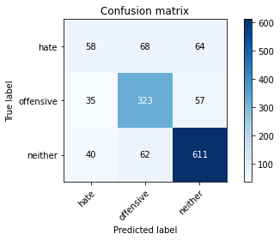

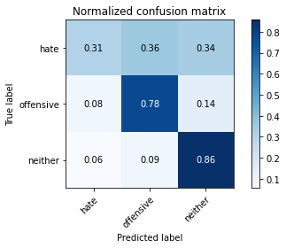

precision recall f1-score support

hate 0.44 0.31 0.36 190

offensive 0.71 0.78 0.74 415

neither 0.83 0.86 0.85 713

accuracy 0.75 1318

macro avg 0.66 0.65 0.65 1318

weighted avg 0.74 0.75 0.74 1318

average eval_loss: 0.591567338867621, accuracy: 0.7526555386949925

training 2 epoch...

59.02708959579468 seconds used......

2 training finished! average train loss: 0.4816429340703921

evaluating...

Confusion matrix, without normalization

[[ 91 62 37]

[ 63 325 27]

[125 60 528]]

Normalized confusion matrix

[[0.47894737 0.32631579 0.19473684]

[0.15180723 0.78313253 0.06506024]

[0.17531557 0.08415147 0.74053296]]

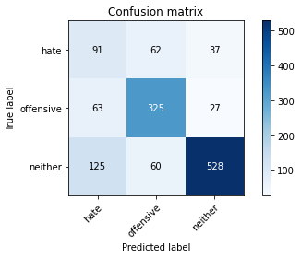

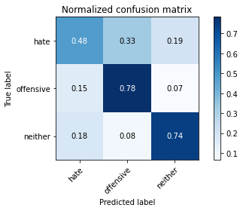

precision recall f1-score support

hate 0.33 0.48 0.39 190

offensive 0.73 0.78 0.75 415

neither 0.89 0.74 0.81 713

accuracy 0.72 1318

macro avg 0.65 0.67 0.65 1318

weighted avg 0.76 0.72 0.73 1318

average eval_loss: 0.6708392342834761, accuracy: 0.716236722306525

training 3 epoch...

59.06537342071533 seconds used......

3 training finished! average train loss: 0.3182411119680513

evaluating...

Confusion matrix, without normalization

[[ 75 65 50]

[ 59 307 49]

[ 75 50 588]]

Normalized confusion matrix

[[0.39473684 0.34210526 0.26315789]

[0.14216867 0.73975904 0.11807229]

[0.10518934 0.07012623 0.82468443]]

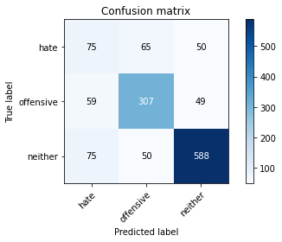

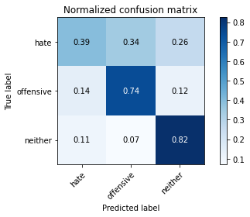

precision recall f1-score support

hate 0.36 0.39 0.38 190

offensive 0.73 0.74 0.73 415

neither 0.86 0.82 0.84 713

accuracy 0.74 1318

macro avg 0.65 0.65 0.65 1318

weighted avg 0.74 0.74 0.74 1318

average eval_loss: 0.6944769598317869, accuracy: 0.7359635811836115

training 4 epoch...

58.98104119300842 seconds used......

4 training finished! average train loss: 0.15847467586070046

evaluating...

Confusion matrix, without normalization

[[ 58 82 50]

[ 45 343 27]

[ 94 81 538]]

Normalized confusion matrix

[[0.30526316 0.43157895 0.26315789]

[0.10843373 0.82650602 0.06506024]

[0.13183731 0.11360449 0.7545582 ]]

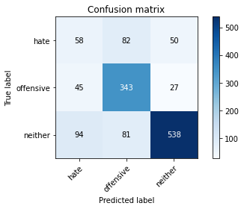

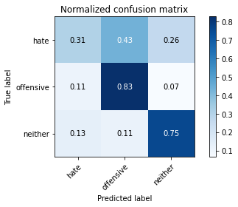

precision recall f1-score support

hate 0.29 0.31 0.30 190

offensive 0.68 0.83 0.74 415

neither 0.87 0.75 0.81 713

accuracy 0.71 1318

macro avg 0.62 0.63 0.62 1318

weighted avg 0.73 0.71 0.72 1318

average eval_loss: 0.9774859561161562, accuracy: 0.712443095599393

training 5 epoch...

58.937427043914795 seconds used......

5 training finished! average train loss: 0.06999481128031303

evaluating...

Confusion matrix, without normalization

[[ 55 54 81]

[ 46 292 77]

[ 45 36 632]]

Normalized confusion matrix

[[0.28947368 0.28421053 0.42631579]

[0.11084337 0.70361446 0.18554217]

[0.0631136 0.05049088 0.88639551]]

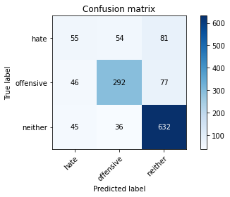

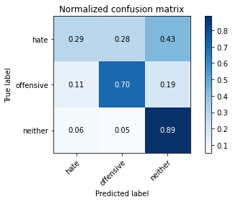

precision recall f1-score support

hate 0.38 0.29 0.33 190

offensive 0.76 0.70 0.73 415

neither 0.80 0.89 0.84 713

accuracy 0.74 1318

macro avg 0.65 0.63 0.63 1318

weighted avg 0.73 0.74 0.73 1318

average eval_loss: 1.0906474427743391, accuracy: 0.7427921092564491

training 6 epoch...

58.92189359664917 seconds used......

6 training finished! average train loss: 0.045240271823290226

evaluating...

Confusion matrix, without normalization

[[ 43 96 51]

[ 32 345 38]

[ 64 90 559]]

Normalized confusion matrix

[[0.22631579 0.50526316 0.26842105]

[0.07710843 0.8313253 0.09156627]

[0.08976157 0.12622721 0.78401122]]

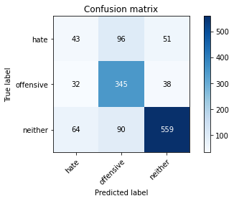

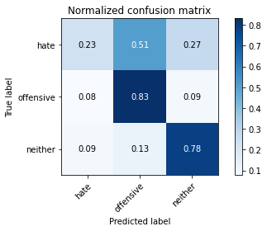

precision recall f1-score support

hate 0.31 0.23 0.26 190

offensive 0.65 0.83 0.73 415

neither 0.86 0.78 0.82 713

accuracy 0.72 1318

macro avg 0.61 0.61 0.60 1318

weighted avg 0.72 0.72 0.71 1318

average eval_loss: 1.2383979762142354, accuracy: 0.7185128983308042

training 7 epoch...

58.979015827178955 seconds used......

7 training finished! average train loss: 0.037183884022736244

evaluating...

Confusion matrix, without normalization

[[ 58 65 67]

[ 46 310 59]

[ 57 58 598]]

Normalized confusion matrix

[[0.30526316 0.34210526 0.35263158]

[0.11084337 0.74698795 0.14216867]

[0.0799439 0.08134642 0.83870968]]

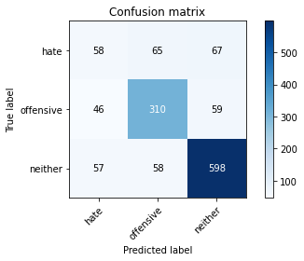

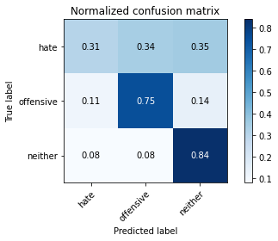

precision recall f1-score support

hate 0.36 0.31 0.33 190

offensive 0.72 0.75 0.73 415

neither 0.83 0.84 0.83 713

accuracy 0.73 1318

macro avg 0.63 0.63 0.63 1318

weighted avg 0.72 0.73 0.73 1318

average eval_loss: 1.1712449554241064, accuracy: 0.7329286798179059

training 8 epoch...

58.992987871170044 seconds used......

8 training finished! average train loss: 0.027458551541150716

evaluating...

Confusion matrix, without normalization

[[ 75 65 50]

[ 50 321 44]

[ 89 56 568]]

Normalized confusion matrix

[[0.39473684 0.34210526 0.26315789]

[0.12048193 0.77349398 0.1060241 ]

[0.12482468 0.07854137 0.79663394]]

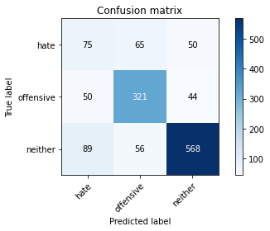

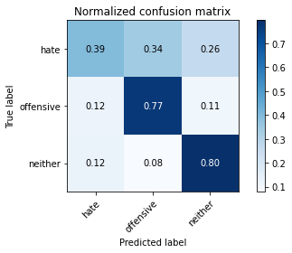

precision recall f1-score support

hate 0.35 0.39 0.37 190

offensive 0.73 0.77 0.75 415

neither 0.86 0.80 0.83 713

accuracy 0.73 1318

macro avg 0.64 0.65 0.65 1318

weighted avg 0.74 0.73 0.74 1318

average eval_loss: 1.2600685493512587, accuracy: 0.7314112291350531

training 9 epoch...

58.93592858314514 seconds used......

9 training finished! average train loss: 0.018558054421009728

evaluating...

Confusion matrix, without normalization

[[ 49 71 70]

[ 44 303 68]

[ 59 45 609]]

Normalized confusion matrix

[[0.25789474 0.37368421 0.36842105]

[0.1060241 0.73012048 0.16385542]

[0.08274895 0.0631136 0.85413745]]

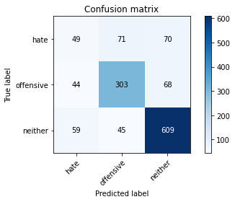

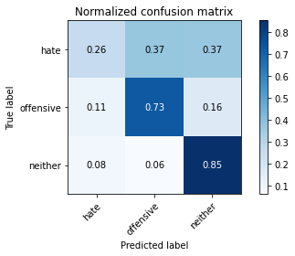

precision recall f1-score support

hate 0.32 0.26 0.29 190

offensive 0.72 0.73 0.73 415

neither 0.82 0.85 0.83 713

accuracy 0.73 1318

macro avg 0.62 0.61 0.62 1318

weighted avg 0.72 0.73 0.72 1318

average eval_loss: 1.3416186291160006, accuracy: 0.7291350531107739

training 10 epoch...

59.07299828529358 seconds used......

10 training finished! average train loss: 0.015821246884892885

evaluating...

Confusion matrix, without normalization

[[ 49 95 46]

[ 33 346 36]

[ 72 99 542]]

Normalized confusion matrix

[[0.25789474 0.5 0.24210526]

[0.07951807 0.83373494 0.08674699]

[0.10098177 0.13884993 0.7601683 ]]

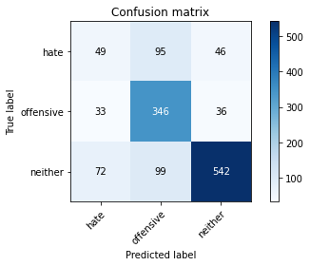

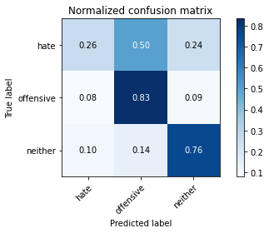

precision recall f1-score support

hate 0.32 0.26 0.28 190

offensive 0.64 0.83 0.72 415

neither 0.87 0.76 0.81 713

accuracy 0.71 1318

macro avg 0.61 0.62 0.61 1318

weighted avg 0.72 0.71 0.71 1318

average eval_loss: 1.6013135882941159, accuracy: 0.7109256449165402

4 run......

training 1 epoch...

59.0340633392334 seconds used......

1 training finished! average train loss: 0.6918263947421854

evaluating...

Confusion matrix, without normalization

[[ 46 99 45]

[ 24 362 29]

[ 63 109 541]]

Normalized confusion matrix

[[0.24210526 0.52105263 0.23684211]

[0.05783133 0.87228916 0.06987952]

[0.08835905 0.15287518 0.75876578]]

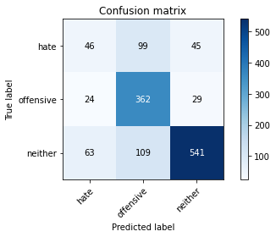

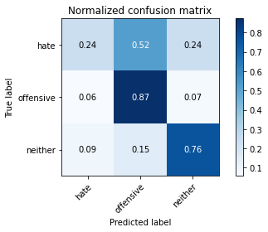

precision recall f1-score support

hate 0.35 0.24 0.28 190

offensive 0.64 0.87 0.74 415

neither 0.88 0.76 0.81 713

accuracy 0.72 1318

macro avg 0.62 0.62 0.61 1318

weighted avg 0.73 0.72 0.71 1318

average eval_loss: 0.6572903503071178, accuracy: 0.720030349013657

training 2 epoch...

59.047725200653076 seconds used......

2 training finished! average train loss: 0.48298777213150806

evaluating...

Confusion matrix, without normalization

[[ 49 97 44]

[ 30 355 30]

[ 85 104 524]]

Normalized confusion matrix

[[0.25789474 0.51052632 0.23157895]

[0.07228916 0.85542169 0.07228916]

[0.11921459 0.14586255 0.73492286]]

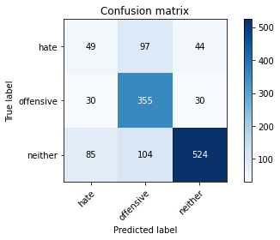

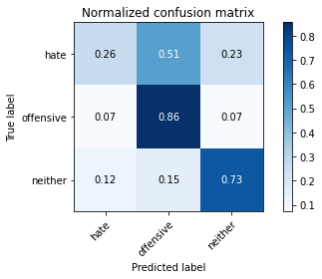

precision recall f1-score support

hate 0.30 0.26 0.28 190

offensive 0.64 0.86 0.73 415

neither 0.88 0.73 0.80 713

accuracy 0.70 1318

macro avg 0.60 0.62 0.60 1318

weighted avg 0.72 0.70 0.70 1318

average eval_loss: 0.6694083155104609, accuracy: 0.7040971168437026

training 3 epoch...

59.07783651351929 seconds used......

3 training finished! average train loss: 0.31974102295935153

evaluating...

Confusion matrix, without normalization

[[ 47 83 60]

[ 28 328 59]

[ 51 60 602]]

Normalized confusion matrix

[[0.24736842 0.43684211 0.31578947]

[0.06746988 0.79036145 0.14216867]

[0.07152875 0.08415147 0.84431978]]

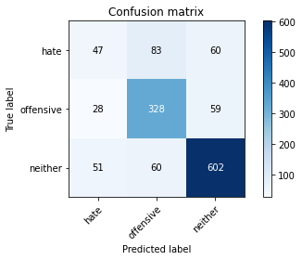

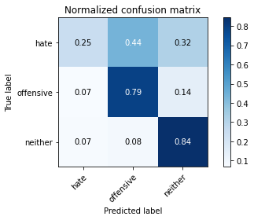

precision recall f1-score support

hate 0.37 0.25 0.30 190

offensive 0.70 0.79 0.74 415

neither 0.83 0.84 0.84 713

accuracy 0.74 1318

macro avg 0.63 0.63 0.63 1318

weighted avg 0.72 0.74 0.73 1318

average eval_loss: 0.7013681928316752, accuracy: 0.7412746585735963

training 4 epoch...

59.044785261154175 seconds used......

4 training finished! average train loss: 0.16754976256792856

evaluating...

Confusion matrix, without normalization

[[ 88 56 46]

[ 78 293 44]

[110 48 555]]

Normalized confusion matrix

[[0.46315789 0.29473684 0.24210526]

[0.18795181 0.7060241 0.1060241 ]

[0.1542777 0.06732118 0.77840112]]

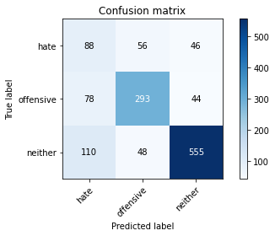

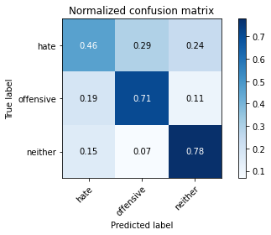

precision recall f1-score support

hate 0.32 0.46 0.38 190

offensive 0.74 0.71 0.72 415

neither 0.86 0.78 0.82 713

accuracy 0.71 1318

macro avg 0.64 0.65 0.64 1318

weighted avg 0.74 0.71 0.72 1318

average eval_loss: 0.8276633911512115, accuracy: 0.7101669195751138

training 5 epoch...

58.974852085113525 seconds used......

5 training finished! average train loss: 0.07272603779777208

evaluating...

Confusion matrix, without normalization

[[ 41 98 51]

[ 27 338 50]

[ 58 80 575]]

Normalized confusion matrix

[[0.21578947 0.51578947 0.26842105]

[0.06506024 0.81445783 0.12048193]

[0.08134642 0.11220196 0.80645161]]

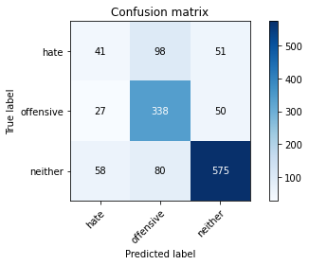

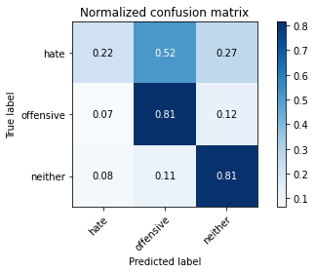

precision recall f1-score support

hate 0.33 0.22 0.26 190

offensive 0.66 0.81 0.73 415

neither 0.85 0.81 0.83 713

accuracy 0.72 1318

macro avg 0.61 0.61 0.60 1318

weighted avg 0.71 0.72 0.71 1318

average eval_loss: 1.0202063062425815, accuracy: 0.723823975720789

training 6 epoch...

59.03619909286499 seconds used......

6 training finished! average train loss: 0.04295441192040347

evaluating...

Confusion matrix, without normalization

[[ 36 98 56]

[ 30 342 43]

[ 56 90 567]]

Normalized confusion matrix

[[0.18947368 0.51578947 0.29473684]

[0.07228916 0.82409639 0.10361446]

[0.07854137 0.12622721 0.79523142]]

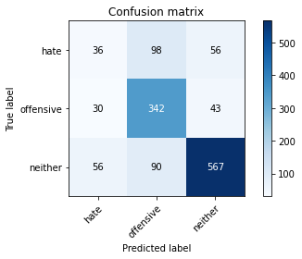

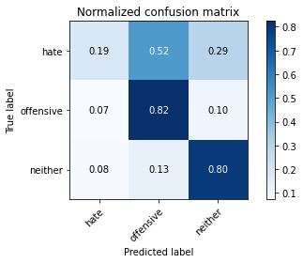

precision recall f1-score support

hate 0.30 0.19 0.23 190

offensive 0.65 0.82 0.72 415

neither 0.85 0.80 0.82 713

accuracy 0.72 1318

macro avg 0.60 0.60 0.59 1318

weighted avg 0.71 0.72 0.71 1318

average eval_loss: 1.1819211014292457, accuracy: 0.7169954476479514

training 7 epoch...

58.97264885902405 seconds used......

7 training finished! average train loss: 0.030833729050904035

evaluating...

Confusion matrix, without normalization

[[ 54 80 56]

[ 50 319 46]

[ 80 71 562]]

Normalized confusion matrix

[[0.28421053 0.42105263 0.29473684]

[0.12048193 0.7686747 0.11084337]

[0.11220196 0.09957924 0.78821879]]

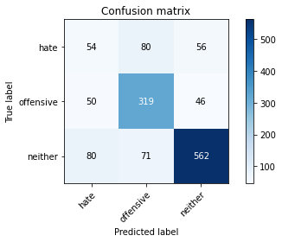

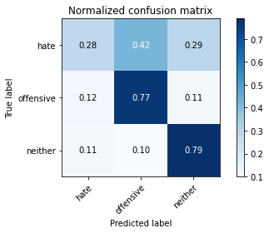

precision recall f1-score support

hate 0.29 0.28 0.29 190

offensive 0.68 0.77 0.72 415

neither 0.85 0.79 0.82 713

accuracy 0.71 1318

macro avg 0.61 0.61 0.61 1318

weighted avg 0.71 0.71 0.71 1318

average eval_loss: 1.2536276533748165, accuracy: 0.7094081942336874

training 8 epoch...

58.95436477661133 seconds used......

8 training finished! average train loss: 0.024416154764582063

evaluating...

Confusion matrix, without normalization

[[ 50 73 67]

[ 57 309 49]

[ 80 54 579]]

Normalized confusion matrix

[[0.26315789 0.38421053 0.35263158]

[0.1373494 0.74457831 0.11807229]

[0.11220196 0.07573633 0.81206171]]

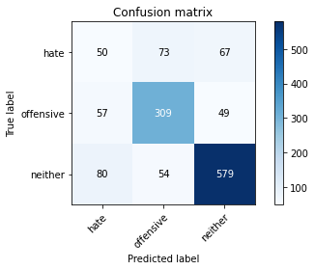

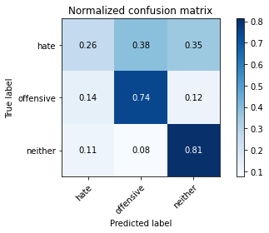

precision recall f1-score support

hate 0.27 0.26 0.27 190

offensive 0.71 0.74 0.73 415

neither 0.83 0.81 0.82 713

accuracy 0.71 1318

macro avg 0.60 0.61 0.60 1318

weighted avg 0.71 0.71 0.71 1318

average eval_loss: 1.2730647181019639, accuracy: 0.7116843702579666

training 9 epoch...

59.02187776565552 seconds used......

9 training finished! average train loss: 0.01663657731941467

evaluating...

Confusion matrix, without normalization

[[ 62 91 37]

[ 48 339 28]

[109 108 496]]

Normalized confusion matrix

[[0.32631579 0.47894737 0.19473684]

[0.11566265 0.81686747 0.06746988]

[0.15287518 0.15147265 0.69565217]]

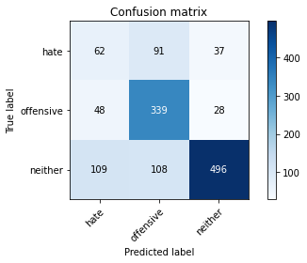

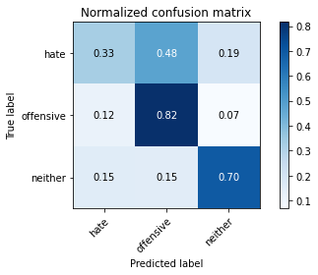

precision recall f1-score support

hate 0.28 0.33 0.30 190

offensive 0.63 0.82 0.71 415

neither 0.88 0.70 0.78 713

accuracy 0.68 1318

macro avg 0.60 0.61 0.60 1318

weighted avg 0.72 0.68 0.69 1318

average eval_loss: 1.584776532920924, accuracy: 0.6805766312594841

training 10 epoch...

59.056538105010986 seconds used......

10 training finished! average train loss: 0.018793355700671036

evaluating...

Confusion matrix, without normalization

[[ 58 70 62]

[ 44 317 54]

[ 63 56 594]]

Normalized confusion matrix

[[0.30526316 0.36842105 0.32631579]

[0.1060241 0.76385542 0.13012048]

[0.08835905 0.07854137 0.83309958]]

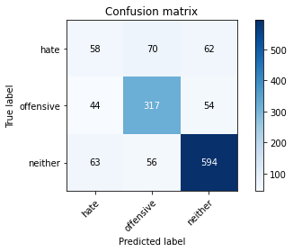

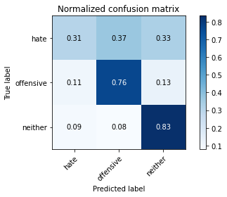

precision recall f1-score support

hate 0.35 0.31 0.33 190

offensive 0.72 0.76 0.74 415

neither 0.84 0.83 0.83 713

accuracy 0.74 1318

macro avg 0.63 0.63 0.63 1318

weighted avg 0.73 0.74 0.73 1318

average eval_loss: 1.3140041812351255, accuracy: 0.7352048558421851

5 run......

training 1 epoch...

58.930044174194336 seconds used......

1 training finished! average train loss: 0.6915361667221243

evaluating...

Confusion matrix, without normalization

[[ 5 119 66]

[ 4 350 61]

[ 9 79 625]]

Normalized confusion matrix

[[0.02631579 0.62631579 0.34736842]

[0.00963855 0.84337349 0.14698795]

[0.01262272 0.11079944 0.87657784]]

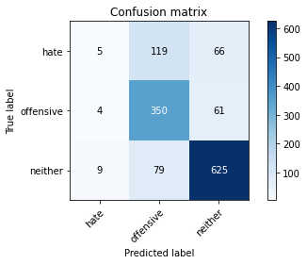

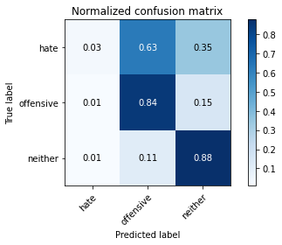

precision recall f1-score support

hate 0.28 0.03 0.05 190

offensive 0.64 0.84 0.73 415

neither 0.83 0.88 0.85 713

accuracy 0.74 1318

macro avg 0.58 0.58 0.54 1318

weighted avg 0.69 0.74 0.70 1318

average eval_loss: 0.6300704325690414, accuracy: 0.7435508345978755

training 2 epoch...

58.9783935546875 seconds used......

2 training finished! average train loss: 0.48259713543070987

evaluating...

Confusion matrix, without normalization

[[ 27 99 64]

[ 6 344 65]

[ 22 71 620]]

Normalized confusion matrix

[[0.14210526 0.52105263 0.33684211]

[0.01445783 0.82891566 0.15662651]

[0.03085554 0.09957924 0.86956522]]

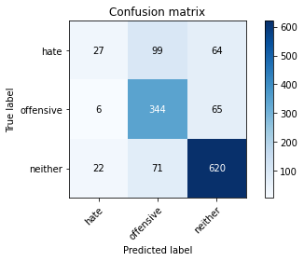

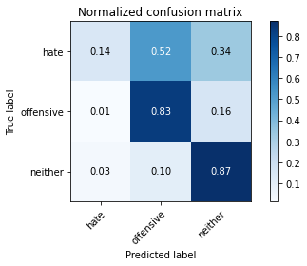

precision recall f1-score support

hate 0.49 0.14 0.22 190

offensive 0.67 0.83 0.74 415

neither 0.83 0.87 0.85 713

accuracy 0.75 1318

macro avg 0.66 0.61 0.60 1318

weighted avg 0.73 0.75 0.72 1318

average eval_loss: 0.6259830047686895, accuracy: 0.7518968133535661

training 3 epoch...

58.98033332824707 seconds used......

3 training finished! average train loss: 0.3273659075525674

evaluating...

Confusion matrix, without normalization

[[ 93 56 41]

[ 69 305 41]

[137 47 529]]

Normalized confusion matrix

[[0.48947368 0.29473684 0.21578947]

[0.16626506 0.73493976 0.09879518]

[0.19214586 0.06591865 0.74193548]]

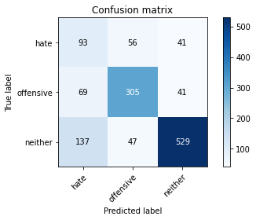

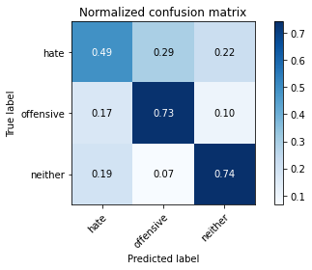

precision recall f1-score support

hate 0.31 0.49 0.38 190

offensive 0.75 0.73 0.74 415

neither 0.87 0.74 0.80 713

accuracy 0.70 1318

macro avg 0.64 0.66 0.64 1318

weighted avg 0.75 0.70 0.72 1318

average eval_loss: 0.7281939251856371, accuracy: 0.7033383915022762

training 4 epoch...

58.957621335983276 seconds used......

4 training finished! average train loss: 0.16656226832842963

evaluating...

Confusion matrix, without normalization

[[108 46 36]

[ 94 282 39]

[128 40 545]]

Normalized confusion matrix

[[0.56842105 0.24210526 0.18947368]

[0.22650602 0.67951807 0.0939759 ]

[0.17952314 0.05610098 0.76437588]]

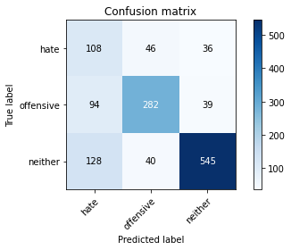

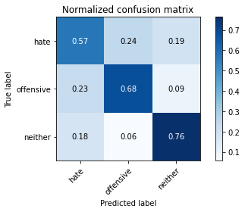

precision recall f1-score support

hate 0.33 0.57 0.42 190

offensive 0.77 0.68 0.72 415

neither 0.88 0.76 0.82 713

accuracy 0.71 1318

macro avg 0.66 0.67 0.65 1318

weighted avg 0.76 0.71 0.73 1318

average eval_loss: 0.912513535582658, accuracy: 0.7094081942336874

training 5 epoch...

58.94177293777466 seconds used......

5 training finished! average train loss: 0.07331797243466347

evaluating...

Confusion matrix, without normalization

[[ 59 83 48]

[ 39 339 37]

[100 89 524]]

Normalized confusion matrix

[[0.31052632 0.43684211 0.25263158]

[0.0939759 0.81686747 0.08915663]

[0.14025245 0.12482468 0.73492286]]

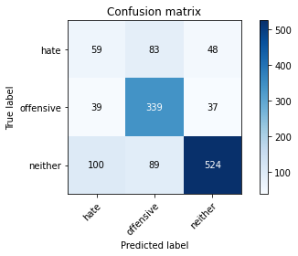

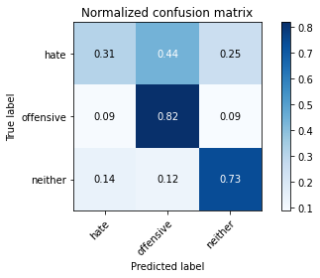

precision recall f1-score support

hate 0.30 0.31 0.30 190

offensive 0.66 0.82 0.73 415

neither 0.86 0.73 0.79 713

accuracy 0.70 1318

macro avg 0.61 0.62 0.61 1318

weighted avg 0.72 0.70 0.70 1318

average eval_loss: 1.2252720486034046, accuracy: 0.6995447647951442

training 6 epoch...

58.97455596923828 seconds used......

6 training finished! average train loss: 0.052846667837266895

evaluating...

Confusion matrix, without normalization

[[ 77 74 39]

[ 52 320 43]

[119 73 521]]

Normalized confusion matrix

[[0.40526316 0.38947368 0.20526316]

[0.1253012 0.77108434 0.10361446]

[0.16690042 0.10238429 0.73071529]]

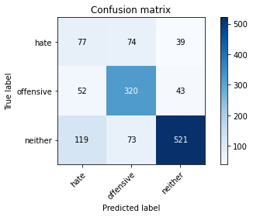

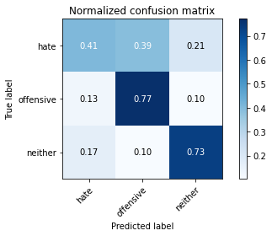

precision recall f1-score support

hate 0.31 0.41 0.35 190

offensive 0.69 0.77 0.73 415

neither 0.86 0.73 0.79 713

accuracy 0.70 1318

macro avg 0.62 0.64 0.62 1318

weighted avg 0.73 0.70 0.71 1318

average eval_loss: 1.1930159416162607, accuracy: 0.6965098634294385

training 7 epoch...

58.94819164276123 seconds used......

7 training finished! average train loss: 0.03519571833815214

evaluating...

Confusion matrix, without normalization

[[ 67 69 54]

[ 54 306 55]

[ 92 47 574]]

Normalized confusion matrix

[[0.35263158 0.36315789 0.28421053]

[0.13012048 0.7373494 0.13253012]

[0.12903226 0.06591865 0.80504909]]

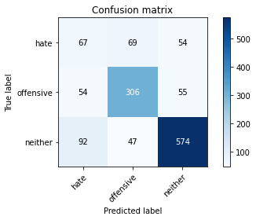

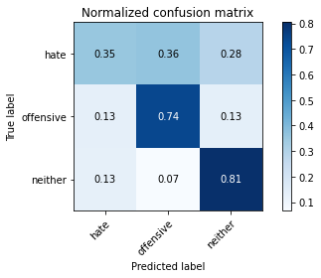

precision recall f1-score support

hate 0.31 0.35 0.33 190

offensive 0.73 0.74 0.73 415

neither 0.84 0.81 0.82 713

accuracy 0.72 1318

macro avg 0.63 0.63 0.63 1318

weighted avg 0.73 0.72 0.72 1318

average eval_loss: 1.3645853066083156, accuracy: 0.7185128983308042

training 8 epoch...

58.95303964614868 seconds used......

8 training finished! average train loss: 0.02235970813701649

evaluating...

Confusion matrix, without normalization

[[ 65 71 54]

[ 61 298 56]

[ 88 46 579]]

Normalized confusion matrix

[[0.34210526 0.37368421 0.28421053]

[0.14698795 0.71807229 0.13493976]

[0.12342216 0.06451613 0.81206171]]

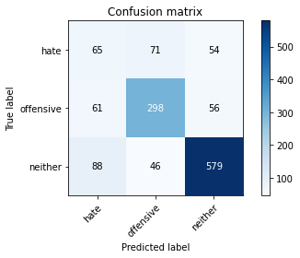

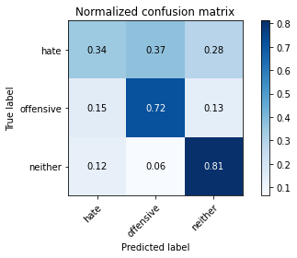

precision recall f1-score support

hate 0.30 0.34 0.32 190

offensive 0.72 0.72 0.72 415

neither 0.84 0.81 0.83 713

accuracy 0.71 1318

macro avg 0.62 0.62 0.62 1318

weighted avg 0.72 0.71 0.72 1318

average eval_loss: 1.3832206653826165, accuracy: 0.7147192716236722

training 9 epoch...

58.95794701576233 seconds used......

9 training finished! average train loss: 0.02769734737230465

evaluating...

Confusion matrix, without normalization

[[ 73 61 56]

[ 57 302 56]

[ 76 56 581]]

Normalized confusion matrix

[[0.38421053 0.32105263 0.29473684]

[0.1373494 0.72771084 0.13493976]

[0.10659187 0.07854137 0.81486676]]

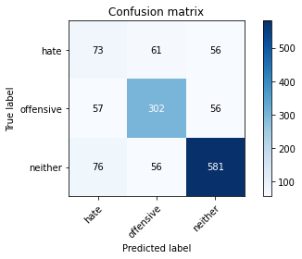

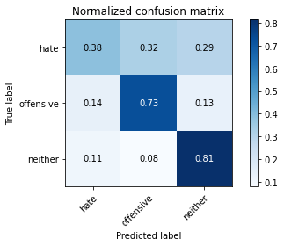

precision recall f1-score support

hate 0.35 0.38 0.37 190

offensive 0.72 0.73 0.72 415

neither 0.84 0.81 0.83 713

accuracy 0.73 1318

macro avg 0.64 0.64 0.64 1318

weighted avg 0.73 0.73 0.73 1318

average eval_loss: 1.357451601913481, accuracy: 0.7253414264036419

training 10 epoch...

59.07915997505188 seconds used......

10 training finished! average train loss: 0.017079320089396787

evaluating...

Confusion matrix, without normalization

[[ 66 70 54]

[ 48 321 46]

[ 96 66 551]]

Normalized confusion matrix

[[0.34736842 0.36842105 0.28421053]

[0.11566265 0.77349398 0.11084337]

[0.13464236 0.09256662 0.77279102]]

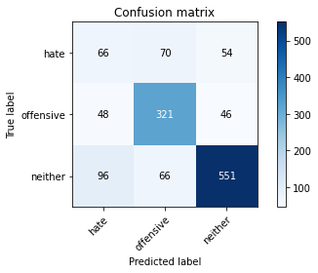

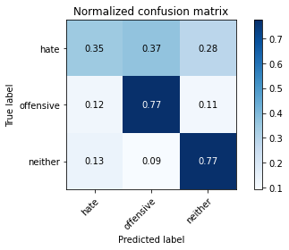

precision recall f1-score support

hate 0.31 0.35 0.33 190

offensive 0.70 0.77 0.74 415

neither 0.85 0.77 0.81 713

accuracy 0.71 1318

macro avg 0.62 0.63 0.62 1318

weighted avg 0.72 0.71 0.72 1318

average eval_loss: 1.4032764922488818, accuracy: 0.7116843702579666